# fhandle_read_file.png

**Our text file**

**FILE HANDLE**

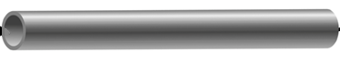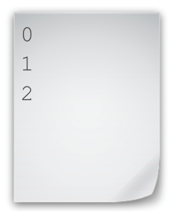

**Our Python program**

**Data In**

**Data Out**

# fhandle_write_file.png

**Our text file**

**FILE HANDLE**



**Our Python program**

**Data Out**

**Data In**

Before closing the file, the data is still not written to the file from buffer

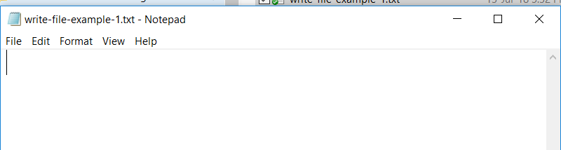

After closing the file using **fhandle.close()**

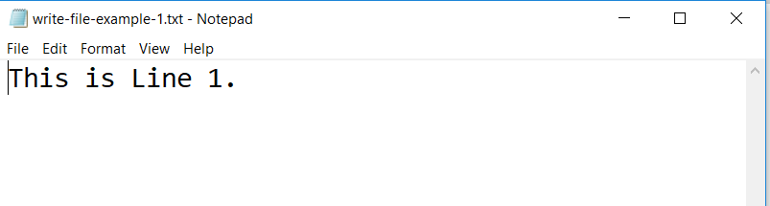

This is Line 1.

This is Line 2.

This is Line 3.

This is Line 4.

**Our Python Program**

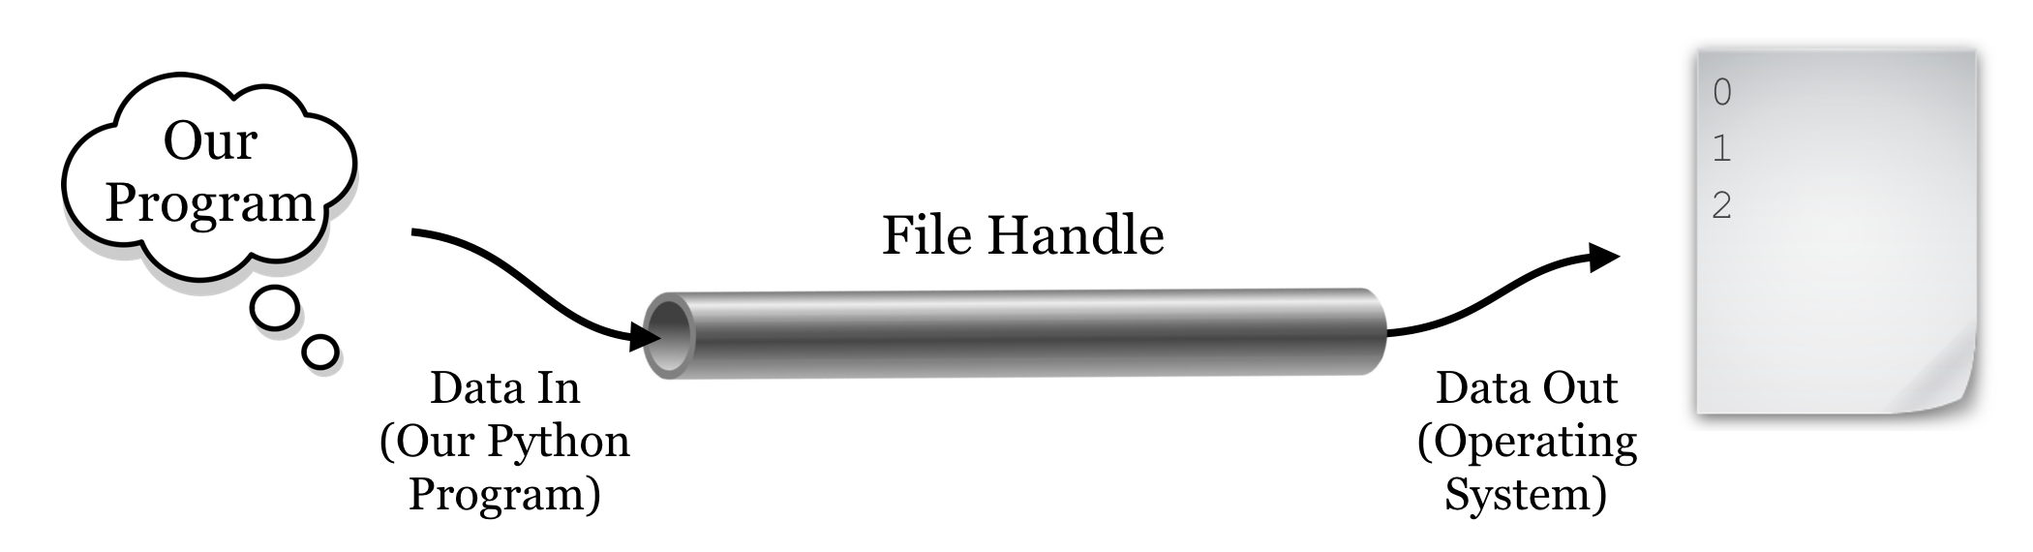

**External Storage**

**USB Flash drive**

**CD-RW**

**Secondary Storage**

**Hard Disk Drive**

**Solid State Drive**

**Primary/Main Storage**

**RAM**

**External Cache**

**CPU**

**Internal Cache**

**Registers**

**Input & Output**

**Keyboard,Mouse**

**Screen**

**Network**

**Ethernet**

**WiFi**